1. Rename the installer from sscmwininstallclient.exe to sscmwininstallclient.zip
2. Extract the contents of sscmwininstallclient.zip to a directory (for future steps the directory will be called sscmwininstallclient). The contents of the directory should be a folder called InstallerData and Windows.
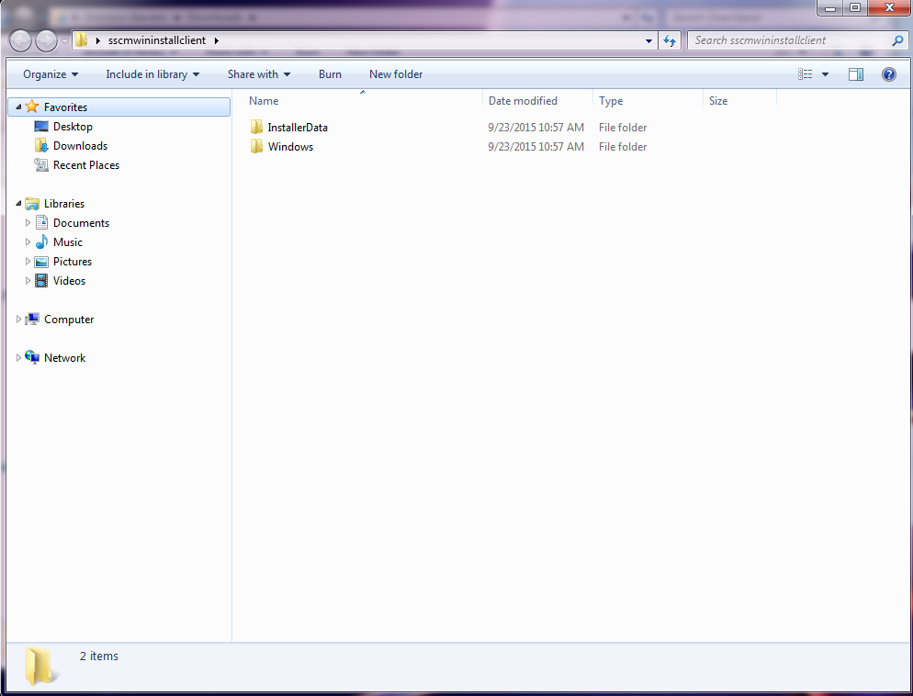
3. Go into the sscmwininstallclient \Windows\resource\jre folder.
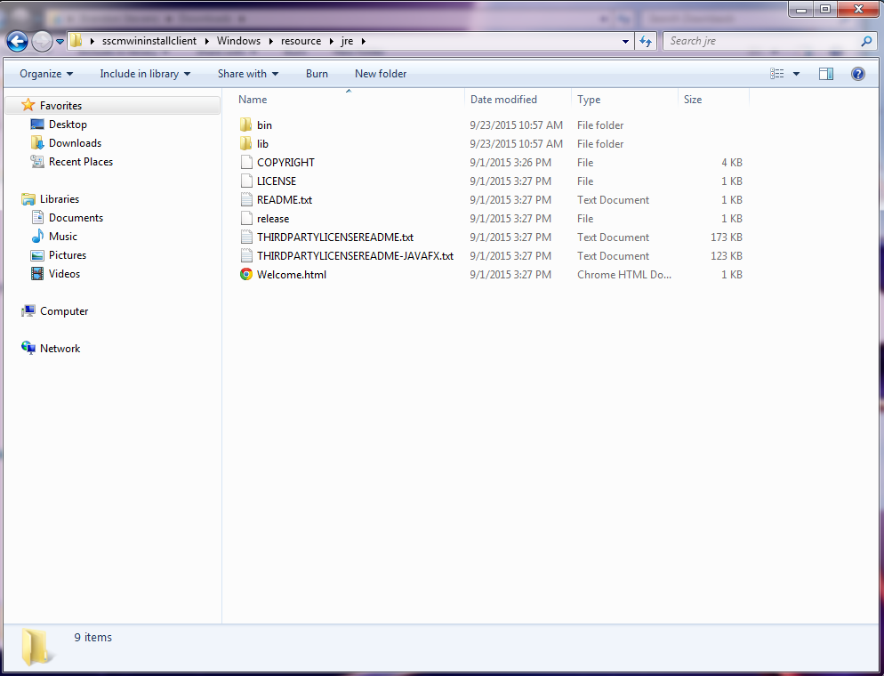
4. Copy the lib and bin folders
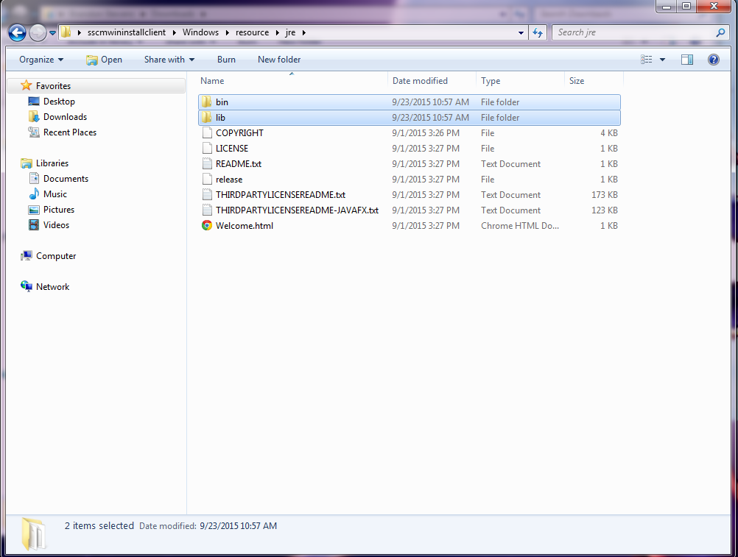
5. Navigate back to the sscmwininstallclient\Windows and paste the lib and bin folders.
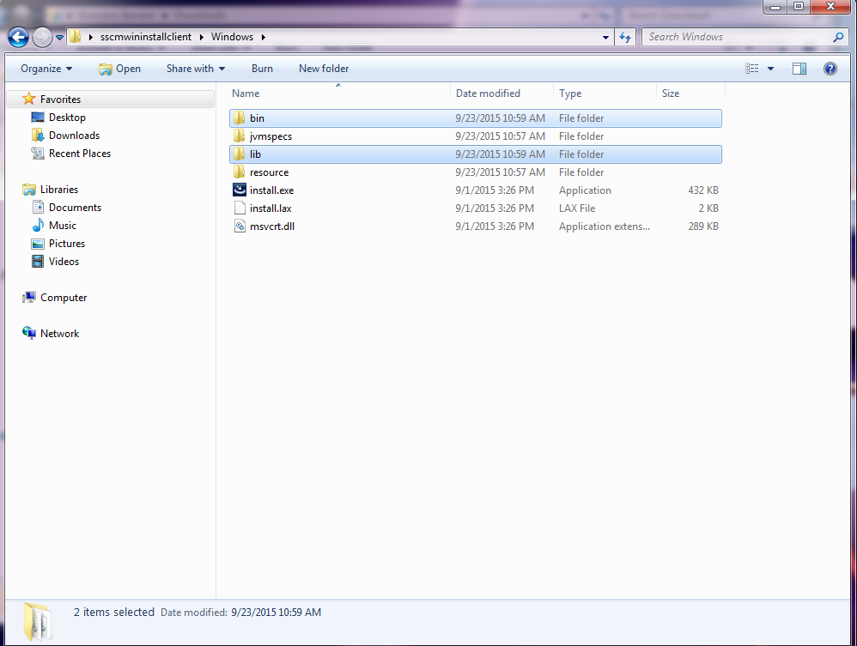
6. Try to run install.exe from a command prompt and see if runs or provides any errors. If you are able to successfully install the Surround Client at this point you can skip the rest of the steps.
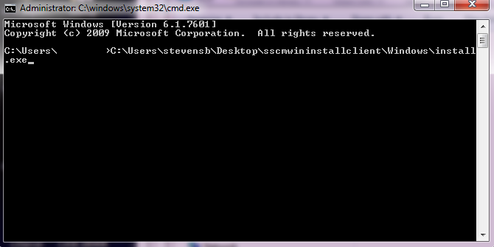
7. If it doesn’t work try editing a file called install.Iax in the sscmwininstallclient\Windows folder. Open the install.Iax file with a text editor like wordpad.exe.
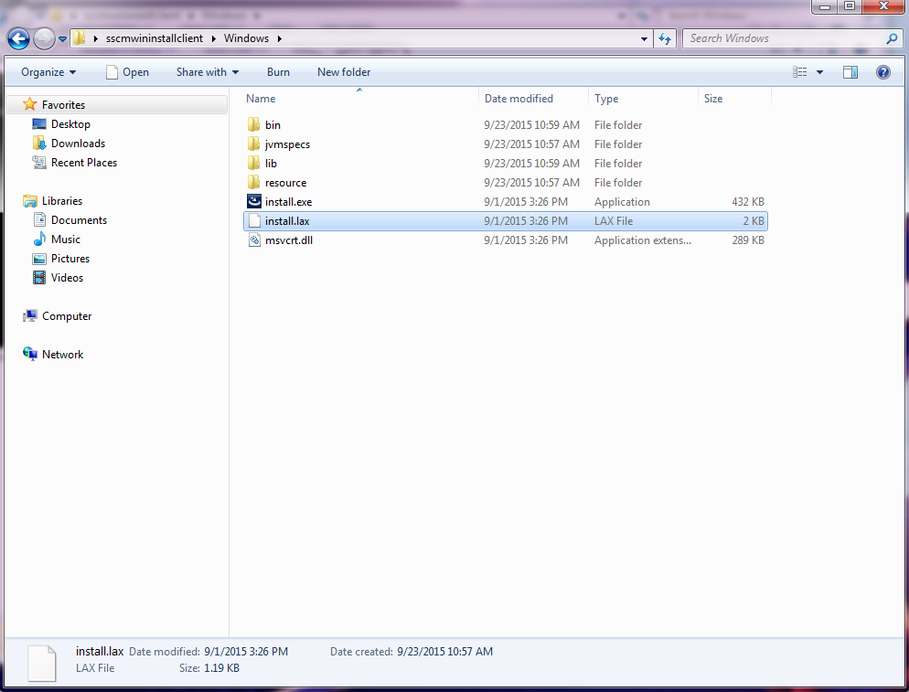
8. There are two strings that determine how much memory are needed to create the java jvm. these are listed below:
lax.nl.java.option.java.heap.size.initial=16777216
lax.nl.java.option.java.heap.size.max= 1073741824
9. Change the string so they have smaller values. In some testing I was able to get the installer to work with the following smaller values. I only changed the max size.
lax.nl.java.option.java.heap.size.initial=16777216
lax.nl.java.option.java.heap.size.max=33741824
10. Open a command prompt and navigate to the sscmwininstallclient
11. Try to run install.exe from a command prompt and see if runs or provides any errors. It should now try to use less memory. If it fails with a java memory error you can try to keep lowering the java heap memory and continue to try running the installer to see if it will work.

